Assignment 3 Part B

**Haozhe Bai S5171326**

**Analysis of word preference in Shakespeare's plays**

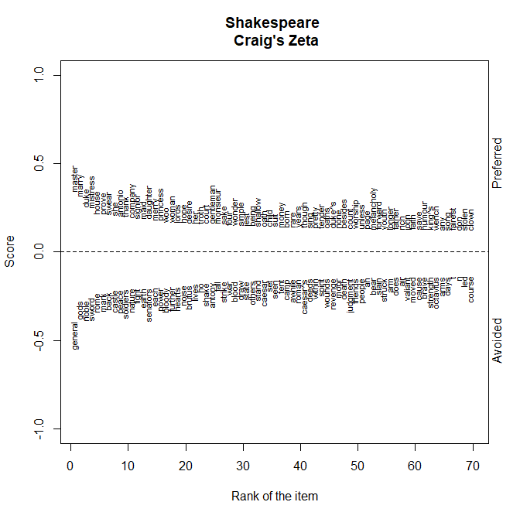

In Shakespeare's plays, comedy uses “master, marry, duke, mistress, house, prove, wear, she, antonio, thank” more often. while the 10 most frequent words in tragedy are “general, gods, noble, sword, rome, mark, back, castle, peace, soldiers”. mark, back, castle, peace, soldiers. the lives depicted in Shakespeare's comedies are more focused on the upper classes of social groups, with more attention paid to the lives of the nobility, merchants, and other classes. nouns such as master, duke, mistress, and house clearly show that the upper classes of society are the main groups depicted in the novels. The frequency of the word general in Shakespeare's tragedies is very high, far more than other words, extremely close to -0.5. The characters in the tragedies are more socially underprivileged and generally have more common people groups. The nouns gods, sword, castle, and soldiers remind me more of the overthrown royals. In addition to Othello, the remaining three works are almost all related to the struggle for kingship, this struggle for power will necessarily involve elements of war, castles, etc. Shakespeare's comedies prefer to use more lifelike terms, such as marry and house. Compared with these words, tragedies prefer to use some words related to military, and this characteristic is very obvious. At the same time, most of these words are nouns, which can reflect the content of the two types of works and the context in which the story takes place. Comedies often use the word thank, a verb that expresses goodwill, which is less frequent in tragedies.

**Analysis of the word preferences of British female and male writers**

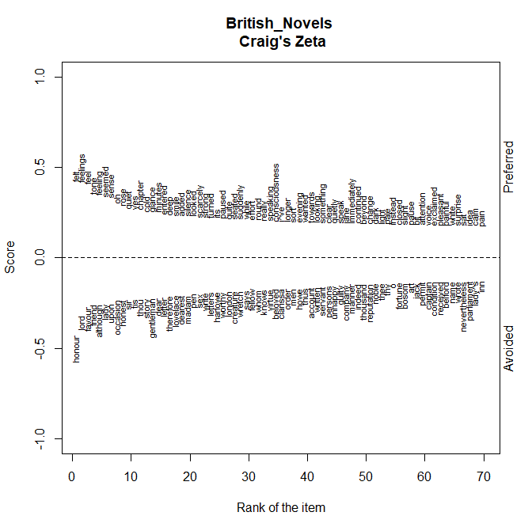

The top 10 words used by female writers are feel, feelings, feel, tone, feeling, seem, sense, oh, rose, quiet. The 10 most used words by male writers are honor, jord, favor, friend, well, lady, upon, occasion, honest, sir. We can find that women writers pay more attention to feelings and senses in the comparison of the words of British male and female writers' works, and the four words feel feelings feeling have the same meaning, including sense oh and other words related to feelings and other meanings. Female writers pay more attention to the depiction of emotions. Female writers are more emotional, while male writers are more rational. Female writers may use more personal names, but men use more pronouns such as gentleman and lady, which are more strict and standardized, and this may also be related to the individual characters and scenes written in the text. In more official settings, pronouns are used more often in conversation, while in family settings, people are referred to more directly by their first names. Women writers use more verbs, such as enter, add, look, turn, pause, and so on. They may prefer to use conversational forms. Male writers, on the other hand, have more nouns as well as adjectives in their writing and are more likely to use declarative sentences to describe the story.

**A Study of Word Preferences in Science Fiction during Different Periods**



This section continues the study of science fiction writers from part A. I have divided the 27 novels into two parts, using time as the criterion. The right-hand side of the image shows the word preferences of the 19c science fiction novels, while the left-hand side shows the word preferences of the post-1950 science fiction novels. Looking at these words, we can see that the 19c science fiction has a preference for many geographical concepts such as sea, south, wind, England, and north, while the preposition towards and the noun captain are all appropriate to the time period. After 1950, however, we can find more words related to modern science in science fiction, such as laboratory, scientist, research, chemical, energy, machine and so on. This change is not unrelated to the great progress of science. Advances in the study of the natural and social sciences have led to changes in the objects and themes of science fiction writing. Developments in the natural sciences have led to an increasing number of ideas based on modern science in science fiction. And the introduction of these novel concepts has in some ways contributed to the spread of new knowledge.